Sunday | Monday | Tuesday  April | Wednesday | Thursday | Friday | Saturday
2  Senses Week | 3 | 4  Explore Sight | 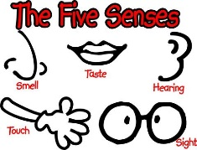  5 | 6  Explore Smell | 7 | 8 FBC services  Sunday School  9:45am  Sunday Service  10:45am  Evening Service  6:00pm
9  Weather  Tommy’s Birthday | 10  Take a walk and see what the weather is like | 11 | 12  Easter breakfast party | 13  Make Tornados | 14Easter Break Daycare Closed  Good Friday | 15
16  Bugs | 17  Easter Break Daycare Closed | 18  Bug Hunt | 19 | 20  Fly Swatter Painting | 21 | 22
23  Rhyming | 24  Teddy Bear, Teddy Bear  Olivia’s Birthday | 25  Little Miss Muffet | 26  Hey Diddle Diddle | 27  Purple Cow | 28  Mary Had a Little Lamb | 29
30  Spring | 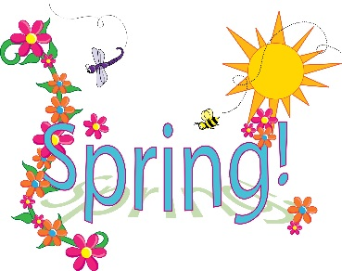 |  | Pick Flowers |  | Enjoy the Sunshine

